Office of Research Assurance
Human Subject Research Protections Guidance

Guidance- 705: ClinicalTrials.gov

Number | Effective Date | Version Number | Previous Versions
705 | 29-Feb-2025 | v.3.1 | v.3

Purpose
The purpose of this document is to provide guidance to assist researchers and IRB staff in determining when a clinical trial must be registered on ClinicalTrials.gov and/or when an informed consent form must be posted on ClinicalTrials.gov. For detailed information regarding the purpose, policy, timelines, and responsible parties for ClinicalTrials.gov registration and posting, please read NASA IRB SOP 700.

Instructions
To determine if a research study is to be registered on ClinicalTrials.gov, answer the question(s) below for each entity. Note, definitions may vary among entities. Please use the definitions column for each corresponding question. To determine if an informed consent form must be uploaded to ClinicalTrials.gov, see the Revised Common Rule Section.

For step-by-step instructions on how to register your study, how to edit your study, and/or how to post your study results on ClinicalTrials.gov, please visit https://clinicaltrials.gov/submit-studies/prs-help.

Revised Common Rule
NASA is a Revised Common Rule Agency. Research studies satisfying the following criteria must upload one, unsigned IRB-approved informed consent form used to enroll participants on a publicly available Federal Web site:
• Studies that meet the Revised Common Rule (14CFR1230) definition of a clinical trial,
• Studies supported by NASA (or other Revised Common Rule agency(ies), and
• Studies approved by the IRB on or after January 21, 2019,
Answer the question below regardless of funding source.
Question | Answer | Definitions
Does your study prospectively  assign one or more human subjects to one or more  interventions (which may include placebo or other control) to  evaluate the effects of the interventions on biomedical or behavioral health-related outcomes? | ☐ No  ☐ Yes | Health-related biomedical or behavioral  outcomes are pre-specified goal(s) or condition(s) that reflect the effect of one or more interventions on human subjects’ biomedical or behavioral status or quality of life.  Examples include:  - Positive or negative changes to  physiological or biological parameters  (e.g. improvement of lung capacity, gene expression);  - Positive or negative changes to  psychological or neurodevelopmental  parameters (e.g. mood management  intervention for smokers, reading  comprehension and/or information  retention);  - Positive or negative changes to disease processes;  - Positive or negative changes to  health-related behaviors; and  - Positive or negative changes to  quality of life

If you answered “no” to the above question, you do not need to post an informed consent form on ClinicalTrials.gov or Regulations.gov. Proceed to the FDAAA Section.

If you answered “yes” to the question above, you must post one blank IRB-approved informed consent form on ClinicalTrials.gov or Regulations.gov as follows:

- For studies that are also registered on Clinicaltrials.gov, and the ICF is written in the English language, that ICF must be posted on Clinicaltrials.gov.
- For studies that are not otherwise registered on Clinicaltrials.gov and/or there is not an English-language ICF, that ICF must be uploaded to a docket folder on Regulations.gov.
- For applicable studies that are part of an analog complement, the NASA IRB Chair and/or delegate will determine whether the individual study ICF or the complement ICF will be posted and by whom.
- For applicable studies that are part of a flight complement, the individual study ICF will be posted, not the complement ICF.

Informed consent forms must be posted once the study is closed to recruitment and 60 or fewer days have passed since the last study visit by any participant. If the study includes multiple informed consent forms, only one informed consent form must be uploaded.

Please refer to the ClinicalTrials.gov SOP 700 for additional details. Instructions for posting an ICF are included in the Appendix of this guidance document. Proceed to the FDAAA Section.

Examples of Studies that are NOT  Revised Common Rule clinical trials | Examples of studies that ARE  Revised Common Rule clinical trials
Studies that are not funded by NASA or  another Revised Common Rule Agency | A study that examines the effect of an intervention on biomedical or behavioral  space-related health outcomes  (i.e. bed rest, hypobaric chamber, parabolic  flight, exercise, drug, biologic, device, dietary supplement).
Retrospective studies | A study that manipulates the environment to  modify biomedical or behavioral space-related health outcomes (i.e. bed rest, hypobaric chamber,  parabolic flight).
Studies intended to solely refine measures | A study that assigns participants to exercise  interventions, mental health interventions,  drug, biologic, or device interventions, to positively or negatively impact physical or  mental health (including quality of life).
Studies that involve secondary research with  biological specimens or health information | A study that examines changes to physiological or biological parameters as a result of an intervention.
Observational studies | A study that examines changes to  disease processes following an intervention
Studies that collect data/biospecimens but do not analyze the data/biospecimens (i.e. repositories)
Studies approved by the IRB prior to January
21, 2019

Food and Drug Administration Amendment Act (FDAAA)
Studies meeting the definition of an applicable clinical trial that either were initiated after September 27, 2007, or initiated on or before that date and were still ongoing as of December 26, 2007, require registration on ClinicalTrials.gov (42CFR11). Use the questions below to determine if your study is considered an applicable clinical trial. Note, funding source is irrelevant.

Question | Answer | Definitions
Does the study evaluate at least  one drug, biological, or device product regulated by the US FDA?  The product must be the  intervention studied or the experimental variable of interest  in the study. | ☐ No  ☐ Yes | Regulated by the US FDA means the drug,  biologic, or device is subject to section  510(k), 515, or 520(m) of the FD&C Act.  A device is considered subject to the above  if any of the following are required before it  may be legally marketed in the US:  1. A finding of substantial equivalence under section 510(k)  2. a premarket approval application (PMA)  for the device product, or  3. A humanitarian device exemption  Device products that are considered subject to the above include:  - significant risk devices for which an  IDE is required,  - non-significant risk devices  considered to have an approved IDE,  or  - device products that are exempt  If the drug, biologic, or device product is manufactured outside of the US or its territories, and the study sites are all outside of the US and territories, and for drugs, the investigation is not conducted under an IND, the product is not an FDA regulated product.  Please check “no.”  A drug or biologic is considered subject to  the above if:  - it is considered the subject of an  approved new drug application  (NDA) or biologic license application  (BLA), or  - it would require an NDA or BLA to be legally marketed in the US  If the investigation of the drug or biologic is  conducted entirely outside of the US or its territories, and the study sites are all outside of the US and territories, the product may not be an FDA regulated product, depending on where the product is manufactured.  Non-prescription drug products that are or  could be marketed under an existing over-  the-counter monograph are not considered  FDA regulated.

If you answered “no” to the above question, the study is not an applicable clinical trial and registration and reporting of results on ClinicalTrials.gov per the FDAAA is not required. Proceed to the NIH section.

If you answered “yes” to the above question, continue with the questions below.
Question | Answer | Definitions
Is the study interventional? | ☐ No  ☐ Yes | An interventional study is a study in which  - participants are assigned prospectively to  an intervention or interventions according to a protocol; and  - the purpose is to evaluate the effect of the intervention(s) on biomedical or other health-related outcomes  Health-related biomedical or behavioral  outcomes are pre-specified goal(s) or condition(s) that reflect the effect of one or more interventions on human subjects’ biomedical or behavioral status or quality of life.  Examples include:  - Positive or negative changes to  physiological or biological parameters (e.g. improvement of lung capacity, gene expression);  - Positive or negative changes to  psychological or neurodevelopmental parameters (e.g. mood management intervention for smokers, reading comprehension and/or information retention);  - Positive or negative changes to disease processes;  - Positive or negative changes to  health-related behaviors; and  - Positive or negative changes to quality of life
Is at least one study facility  located in the US or US territory?  OR  Is the study conducted under a  US FDA IND or IDE?  OR  Does the study involve a drug, biological, or device product that is manufactured in and exported form the Us or US territory for study in another country? | ☐ No to all  ☐ Yes to  one or more | US and US territories includes: the 50 United States, the District of Columbia, Puerto Rico, Guam, the Virgin Islands, American Samoa, or other US territory. Flight research studies are considered to be conducted in a US or US territory if:  - There are pre- and post-flight research activities conducted in a US or US territory, and/or  - There are in-flight research activities and identifiable/attributable data are transferred to, held, and/or analyzed by Principal Investigators (PIs) located in a US or US territory  If the device/drug is manufactured in the US or US territory and exported for study in another country, it may be considered an applicable clinical trial if all other criteria are met.  If the device/drug is manufactured outside of the US or US territories and all study sites are outside of the US or US territories, select “no.” The study is not considered an applicable clinical trial.  Devices/drugs packaged and/or labeled in the US or US territories may be considered an applicable clinical trial if all other criteria are met.
1
Note: Devices/drugs/biologics that are considered FDA-regulated for ground studies, in which the intervention is only being studied on ISS, are not considered FDA-regulated and thus would not be an applicable clinical trial unless the PI wishes to market in the US.

National Institutes of Health (NIH)
Research studies funded by the National Institutes of Health (NIH) initiated on or after January 18, 2017, meeting the NIH definition of a clinical trial, must be registered on ClinicalTrials.gov. The NIH definition of a clinical trial is broad. Answer the following questions regardless of the study phase or type of study intervention:

Question | Answer
Is the study funded in whole or in part by the NIH? | ☐ No  ☐ Yes

If you answered “no” to the above question, registration and reporting of results on ClinicalTrials.gov per the NIH are not required. Proceed to the ICMJE section.

If you answered “yes” to the above question, continue with the questions below.

Question | Answer | Definitions
Does the study involve one or  more human participants? | ☐ No  ☐ Yes | Please see SOP 405 for guidance.
Are the participants prospectively assigned to an intervention? | ☐ No  ☐ Yes | Prospectively assigned is a pre-defined process (e.g. randomization) specified in an approved protocol that stipulates the assignment of research subjects (individually or in clusters) to one or more arms (e.g. intervention, placebo, or other control) of a clinical trial.
Is the study designed to evaluate  the effect of the intervention on  the participants? | ☐ No  ☐ Yes | An intervention is a manipulation of the subject or subject’s environment for the purpose of modifying one or more health-related biomedical or behavioral processes and/or endpoints.
Is the effect being evaluated a health-related biomedical or behavioral outcome? | ☐ No  ☐ Yes | Health-related biomedical or behavioral  outcomes (NIH) – pre-specified goal(s) or  condition(s) that reflect the effect of one or more interventions on human subjects’ biomedical or behavioral status or quality of life.  Examples include:  - Positive or negative changes to  physiological or biological parameters (e.g. improvement of lung capacity, gene expression);  - Positive or negative changes to  psychological or neurodevelopmental parameters (e.g. mood management intervention for smokers, reading comprehension and/or information retention);  - Positive or negative changes to disease processes;  - Positive or negative changes to  health-related behaviors; and  - Positive or negative changes to quality of life

If you answered “no” to any of the above questions, the study is not a clinical trial per the NIH definition and registration and reporting of results on ClinicalTrials.gov are not required. Proceed to the ICMJE section.

If you answered “yes” to all of the questions above, registration on ClinicalTrials.gov and subsequent posting of results following data collection are required regardless of whether:
- The trial was terminated
- You are studying healthy participants
- Your study does not have a comparison group (either placebo or control)
- Your study is only designed to assess pharmacokinetics, safety, and/or maximum tolerated dose of an investigational drug
- Your study is a feasibility or pilot study
- Your study is utilizing a behavioral intervention
- Only one aim or sub-aim of your study meets the NIH clinical trial definition

Please refer to the ClinicalTrials.gov SOP 700 for details on registration, posting, and timelines. Instructions for registration are included in the Appendix of this guidance document. You may also click here for additional information.

Examples of Studies that are NOT  NIH clinical trials | Examples of studies that ARE  NIH clinical trials
Any study not funded in whole or in part by  the NIH | A study funded in whole or in part by the NIH  that manipulates the environment to modify biomedical or behavioral space-related health outcomes (i.e. bed rest, hypobaric chamber, parabolic flight).
Retrospective studies | A study funded in whole or in part by the NIH  that assigns participants to exercise  interventions, mental health interventions,  drug, biologic, or device interventions, to positively or negatively impact physical or  mental health (including quality of life).
Clinical trials that only use NIH-supported infrastructure but do not receive NIH funds to support its conduct (P30, P50 grants) | A study funded in whole or in part by the NIH  that examines changes to physiological or  biological parameters as a result of an  intervention.
Studies intended to solely refine measures | A study funded in whole or in part by the NIH that that examines changes to disease processes following an intervention
Studies that involve secondary research with
biological specimens or health information
Observational studies
Studies approved by the IRB prior to January
18, 2017

International Committee of Medical Journal Editors (ICMJE)
Research studies to be published in International Committee of Medical Journal Editors (ICMJE) member journals, meeting the definition of a clinical trial per ICMJE, require registration on ClinicalTrials.gov. Note, funding source is irrelevant. Answer the following question regardless of the study phase or type of study intervention:

Question | Answer
Is there intent to publish study findings in an ICMJE journal? | ☐ No  ☐ Yes

If you answered “no” to the above question, registration and reporting of results on ClinicalTrials.gov per ICMJE are not required. Review the summary section.

If you answered “yes” to the above question, continue with the questions below.

Question | Answer | Definitions
Does your study prospectively  assign people or a group of  people to an intervention, with or without concurrent comparison or control groups, to study the relationship between a health-related intervention and a health outcome? | ☐ No  ☐ Yes | Prospective assignment is a pre-defined process (e.g. randomization) specified in an approved protocol that stipulates the assignment of research subjects (individually or in clusters) to one or more arms (e.g. intervention, placebo, or other control) of a clinical trial.  A health-related intervention modifies a  biomedical or health-related outcome  (e.g. drugs, surgical procedures, devices,  behavioral treatments, educational programs, dietary interventions, quality improvement interventions, and process-of-care changes).  A health outcome is any biomedical or  health-related measure obtained in patients or participants, including pharmacokinetic measures and adverse events.

If you answered “no” to the above question, the study is not a clinical trial, per the ICMJE definition, and registration on ClinicalTrials.gov is not required. Proceed to the Summary section.

If you answered “yes” to the question above, registration on ClinicalTrials.gov is required. Please refer to the ClinicalTrials.gov SOP 700 for details on registration, posting, and timelines. Instructions for registration are included in the Appendix of this guidance document. Registration for ICMJE requires certain data elements (visit ICMJE for guidance.).

Examples of Studies that are NOT  ICMJE clinical trials | Examples of studies that ARE  ICMJE clinical trials
Studies that are not intended to be published  in an ICMJE Journal | A study that manipulates the environment to  modify biomedical or health/space-related health outcomes (i.e. bed rest, hypobaric chamber, parabolic flight) where the researcher intends to publish in an ICMJE Journal
Observational/exploratory studies | A study that assigns participants to exercise  interventions, mental health interventions,  drug, biologic, or device interventions, to positively or negatively impact physical or  mental health (including quality of life) where  the researcher intends to publish in an ICMJE  Journal.
Retrospective studies | A study that examines changes to  physiological or biological parameters as a  result of an intervention (including quality improvement interventions and process of  care changes) where the researcher intends to publish in an ICMJE Journal.
Studies intended to solely refine measures | A study that examines changes to  disease processes following an intervention where the researcher intends to publish in an ICMJE Journal.
Studies that involve secondary research with biological specimens or health information

Informed Consent Language
Below, templated language for the informed consent form is provided for each scenario.

(FDAAA) If the study is interventional and evaluating an FDA-regulated product (regardless of funding source):
“A description of this clinical trial will be available on http://www.ClinicalTrials.gov, as required by US law. This website will not include information that can identify you. At most, this website will include a summary of the study results. You can search this website at any time.”
If the study is an NIH funded clinical trial that is not evaluating an FDA-regulated product:
“A description of this clinical trial will be available on http://www.ClinicalTrials.gov. This website will not include information that can identify you. At most, this website will include a summary of the study results. You can search this website at any time.”
Note: NIH funded trials meeting the FDAAA definition of an applicable clinical trial (intervention evaluating an FDA-regulated product) must use the FDAAA informed consent language provided above.

If the clinical trial (per ICMJE) is to be published in an ICMJE journal but is not an intervention of an FDA-regulated product, nor a clinical trial funded by NIH:
“A description of this clinical trial will be available on http://www.ClinicalTrials.gov. This website will not include information that can identify you. You can search this website at any time.”

Note: Studies to be published in ICMJE that also meet the FDAAA definition of an applicable clinical trial must use the FDAAA informed consent language provided above.

If the clinical trial is funded by a Common Rule Agency (such as NASA):
“A blank informed consent form will be made available on [Clinicaltrials.gov /Regulations.gov]. This website will not include any information that can identify you. You can search this website at any time.”

Summary
 | Entity | ClinicalTrials.gov Requirement
Requirements satisfied | FDAAA | Registration and results posting
Requirements satisfied | NIH | Registration and results posting
Requirements satisfied | ICMJE | Registration
Requirements satisfied | Revised Common Rule | Posting of one, blank ICF

Studies that fall under multiple categories above only need to be registered and/or have results posted to ClinicalTrials.gov once. Studies meeting the FDAAA, NIH, and/or ICJME definition of an applicable clinical trial or clinical trial, also meeting the Revised Common Rule definition of a clinical trial, must follow all regulatory or policy mandates for registration, resulting posting, and informed consent posting on ClinicalTrials.gov.

Please refer to the ClinicalTrials.gov SOP 700 for details. See the Appendix for guidance on registration and/or posting of results and ICF forms.

The table below provides a summary of the detailed information for each entity provided in SOP 700.

 | FDAAA | NIH | ICMJE
Mandate | Regulation | Policy | Policy
Registration Required | Yes | Yes | Yes
Registration deadline | Prior to enrollment  of first subject* | Prior to enrollment  of first subject* | Prior to enrollment of first subject*
Results Reporting Required | Yes | Yes | No
Dependent on Funding | No | Yes | No
Type of intervention | FDA-regulated products | All | All
Study Phase | Not Phase 0,1  Not device  feasibility | All | All
Penalty | Civil monetary and criminal | Loss of funding | Publication rejection

*NASA policy

Definitions
- Applicable clinical device trial (42CFR11.10(a)) –
(1) A prospective clinical study of health outcomes comparing an intervention with a device product subject to section 510(k), 515, or 520(m) of the Federal Food, Drug, and Cosmetic Act (21 U.S.C. 360(k), 21 U.S.C. 360e, 21 U.S.C. 360j(m)) against a control in human subjects (other than a small clinical trial to determine the feasibility of a device product, or a clinical trial to test prototype device products where the primary outcome measure relates to feasibility and not to health outcomes);
(2) A pediatric postmarket surveillance of a device product as required under section 522 of the Federal Food, Drug, and Cosmetic Act (21 U.S.C. 3601); or
(3) A clinical trial of a combination product with a device primary mode of action under 21 CFR part 3, provided that it meets all other criteria of the definition under this part.
- Applicable clinical drug trial (42CFR11.10(a)) – a controlled clinical investigation, other than a phase 1 clinical investigation, of a drug product subject to section 505 of the Federal Food, Drug, and Cosmetic Act (21 U.S.C. 355) or a biological product subject to section 351 of the Public Health Service Act (42 U.S.C. 262), where “clinical investigation” has the meaning given in 21 CFR 312.3 and “phase 1” has the meaning given in 21 CFR 312.21. A clinical trial of a combination product with a drug primary mode of action under 21 CFR part 3 is also an applicable drug clinical trial, provided that it meets all other criteria of the definition under this part.
- Clinical investigation (21CFR50.3(c)) – any experiment that involves a test article and one or more human subjects and that is either subject to requirements for prior submission to the Food and Drug Administration under section 505(i) or 520(g) of the act, or that is not subject to the requirements for prior submission to the Food and Drug Administration under these sections of the act, but the results of which are intended to be submitted later to, or held for inspection by, the Food and Drug Administration as part of an application for a research or marketing permit.
- Clinical Trial (ICMJE) – any research project that prospectively assigns people or a group of people to an intervention, with or without concurrent comparison or control groups, to study the relationship between a health-related intervention and a health outcome.
- Clinical Trial (NIH) – a research study in which one or more human subjects are prospectively assigned to one or more interventions (which may include placebo or other control) to evaluate the effects of those interventions on health-related biomedical or behavioral outcomes.
- Clinical Trial (Revised Common Rule, 14CFR1230.102(b)) – a research study in which one or more human subjects are prospectively assigned to one or more interventions (which may include placebo or other control) to evaluate the effects of the interventions on biomedical or behavioral health-related outcomes.
- Collaborator (ClinicalTrials.Gov) -- An organization providing support for a project by way of funding, design, implementation, data analysis or reporting.
- Enrollment – a study participant is considered enrolled in a research study after he/she/they or a legally authorized representative completes the informed consent process as defined by 14CFR1230/21CFR50. Those screened to determine eligibility, but do not participate in the study, are not considered enrolled.
- Expanded access – “compassionate use” protocols where a patient with a serious/life threatening disease is given access to an investigational product.
- Health-related biomedical or behavioral outcomes (NIH) – pre-specified goal(s) or condition(s) that reflect the effect of one or more interventions on human subjects’ biomedical or behavioral status or quality of life. Examples include:
  - Positive or negative changes to physiological or biological parameters (e.g. improvement of lung capacity, gene expression);
  - Positive or negative changes to psychological or neurodevelopmental parameters (e.g. mood management intervention for smokers, reading comprehension and/or information retention);
  - Positive or negative changes to disease processes;
  - Positive or negative changes to health-related behaviors; and
  - Positive or negative changes to quality of life
- Health-related Intervention (ICMJE) – an intervention used to modify a biomedical or health-related outcome (e.g. drugs, surgical procedures, devices, behavioral treatments, educational programs, dietary interventions, quality improvement interventions, and process-of-care changes).
- Health outcomes (ICMJE) – any biomedical or health-related measures obtained in patients or participants, including pharmacokinetic measures and adverse events.
- Individual site status – the status of the clinical trial at a single study site (e.g. recruiting, active, completed).
- Institutional Review Board (IRB) status – the determination status of the IRB protocol (approved, suspended, disapproved, etc.)
- Intervention (NIH) – a manipulation of the subject or subject’s environment for the purpose of modifying one or more health-related biomedical or behavioral processes and/or endpoints. Examples include:
  - Drugs/small molecules/compounds;
  - Biologics
  - Devices
  - Procedures (e.g. surgical techniques);
  - Delivery systems (telemedicine, face to face interviews);
  - Strategies to change health-related behavior (e.g. diet, cognitive therapy, exercise, development of new habits);
  - Treatment strategies;
  - Prevention strategies; and
  - Diagnostic strategies
- Interventional Study – a study in which participants are assigned prospectively to an intervention or interventions according to a protocol to evaluate the effect of the intervention(s) on biomedical or other health-related outcomes (42CFR11.10(a))
- Phase 1 clinical investigation (21CFR312.21) – initial introduction of an investigational new drug into humans. Phase 1 studies are typically closely monitored and may be conducted in patients or normal volunteer subjects. These studies are designed to determine the metabolism and pharmacologic actions of the drug in humans, the side effects associated with increasing doses, an, if possible, to gain early evidence on effectiveness. During phase 1, sufficient information about the drug’s pharmacokinetics and pharmacological effects should be obtained to permit the design of well-controlled, scientifically valid, Phase 2 studies. Phase 1 studies also include studies of drug metabolism, structure-activity relationships, and mechanism of action in humans, as well as studies in which investigational drugs are used as research tools to explore biological phenomena or disease processes.
- Pre-clinical (Phase 0) investigation – a study designed to be conducted prior to phase 1 and has very limited human exposure with participants only receiving sub-therapeutic doses
- Primary Completion Date - the date the final study participant was examined or received an intervention for the purpose of the final collection of data for the primary outcome.
- Prospectively assigned (NIH) – a pre-defined process (e.g. randomization) specified in an approved protocol that stipulates the assignment of research subjects (individually or in clusters) to one or more arms (e.g. intervention, placebo, or other control) of a clinical trial
- Record verification date – the date on which the responsible party last verified the clinical study information in the entire ClinicalTrials.gov record for the clinical study, even if no additional or updated information is being submitted.
- Research activities – activities that include participant enrollment, recruitment, informed consent, data collection, data analysis/storage of identifiable/attributable data, and the sharing of identifiable/attributable data
- Recruitment status – the recruitment status for the clinical study as a whole, based upon recruitment at of the individual sites (e.g. not yet recruiting, recruiting, completed). If at least one facility in a multi-site clinical trial has a status of “recruiting” then the overall recruitment status should be “recruiting.”
- Responsible Party - the sponsor of the clinical trial or applicable clinical trial unless and until a principal investigator has been designated the Responsible Party in accordance with 42CFR11.4(c)(2)
- Sponsor – a person who initiates a clinical investigation, but who does not actually conduct the investigation, i.e., the test article is administered or dispensed to or used involving, a subject under the immediate direction of another individual. A person other than an individual (e.g., corporation or agency) that uses one or more of its own employees to conduct a clinical investigation it has initiated is considered to be a sponsor (not a sponsor-investigator), and the employees are considered to be investigators.
- Sponsor-investigator – an individual who both initiates and actually conducts, alone or with others, a clinical investigation, i.e., under whose immediate direction the test article is administered or dispensed to, or used involving, a subject. The term does not include any person other than an individual, e.g., corporation or agency.
- Study initiation – the date on which the first human subject is enrolled
- Study completion date – the date that the final study participant was examined or received an intervention for the purpose of the final collection of data for the primary and secondary outcome measures and adverse events.

References
ClinicalTrials.gov
ICMJE.org
FDAAA
FDAMA
14CFR1230/21CFR50
21CFR312
Grants.nih.gov
42CFR11
Collaborative Institute Training Initiative

Version # | Version Notes: | Originated By: | Approved By: | Date Approved:
v.3.1 | Added language regarding timeline requirements for posting of ICF for RCR clinical trials | J. Green | J. Kisenwether | 30April2025
v.3 | Reference added for registration/posting instructions | J. Kisenwether | J. Kisenwether | 27March2025
v.2 | Removal of Appendix section | A. Garza | M. Covington | 04Feb2025
v.1.1 | Add example to RCR | J. Green/A. Garza | J. Green | 03Nov2023
v.1 | Original | J. Kisenwether / P. Weitzel | M. Covington | 1Apr2023

Informed Consent Posting on Regulations.Gov
The following instructions are applicable only for studies that do not require registration on ClinicalTrials.Gov, but do require public posting of an Informed Consent Form (ICF) document.
Only one copy of the ICF form should be posted. This should be the IRB-approved version used to enroll participants – it should be in English, blank, and unsigned. In no circumstances may it contain any participants’ personally identifying information. If the form contains any study-related proprietary or confidential information that should not be posted publicly, please confirm the appropriateness of any desired redactions with the NASA IRB Office prior to uploading.
You may upload ICF documents in Word or PDF format. If uploading a Word Doc, please ensure all comments and tracking are removed from the file prior to uploading.
ICFs posted publicly via this method are appended as comments to the US Department of Health & Human Services Regulations.gov Docket # HHS-OPHS-2018-2021.

To post your ICF on Regulations.Gov:
- Access the docket at the following link: https://www.regulations.gov/docket/HHS-OPHS-2018-0021
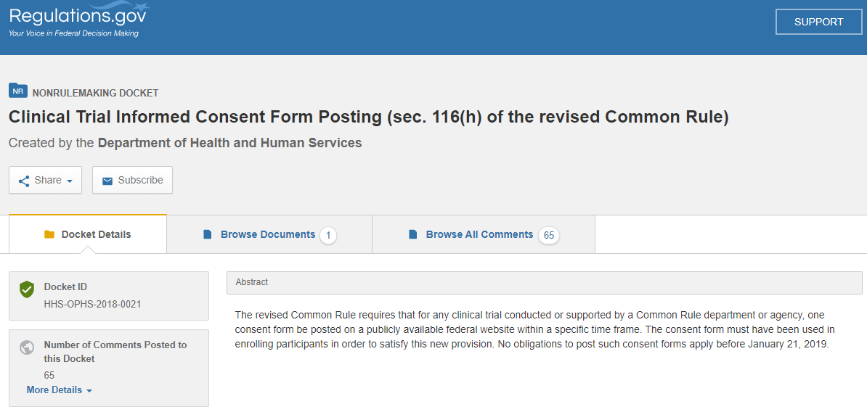
- Click on the “Browse Documents” section

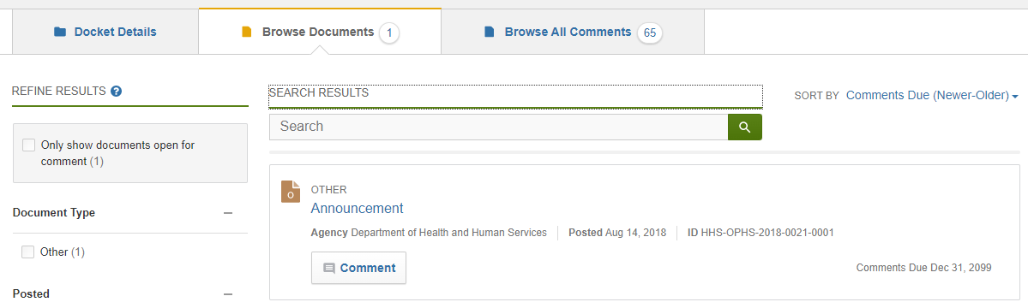

- Under the “Announcement” entry, click the button labeled “Comment.”
- On the page that appears, scroll past the “Comment” box to the section labeled “Attach Files.” No text comments are necessary for submitting an ICF document to this docket.

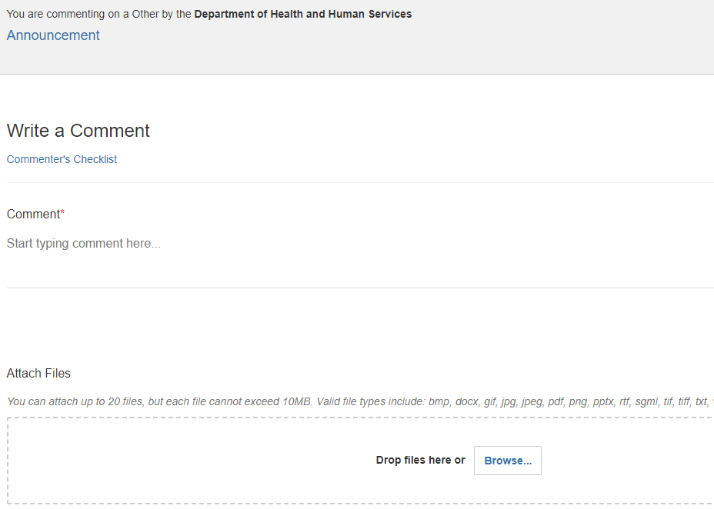



- Click “Browse…” or Drag and Drop from a file explorer window to select the ICF document you wish to upload.
- You may enter your email address if you would like an emailed confirmation of your comment submission and tracking number. This is optional.
In the following section, select “Anonymous.” Posting of consent forms does not require contact information for the submitting individual, as all pertinent information will be available in the consent form itself.
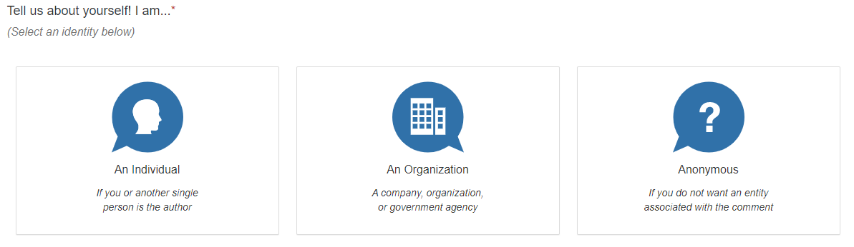
- Complete the CAPTCHA if necessary and then click “Continue”

- You will be taken to a preview page where you will review the information you provided. Click the checkbox next to the disclaimer statement that reminds you any information you submit will be publicly available on the internet, and then click “Submit Comment.”
- Your confirmation page will contain a comment tracking number. If you did not input your email address to have this information sent to you, please make a note of this number for your records.

